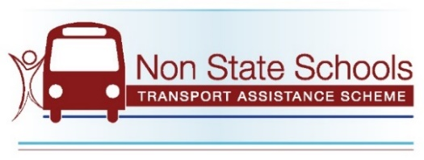
Student Travel Rebates

Semester 1

Visit our website to see if you qualify for our financial
assistance to help with the cost of transport and
apply at SchoolTransport.com.au during May.

Late applications cannot be accepted after 31st May.

Students With Disability
- Does your child have a
verified disability that requires transport assistance to and from school?
- Has your school’s learning support teacher assessed your child’s travel capability rating as ‘semi-independent’ or more dependent?

Bus Fare
Assistance
- Does your child attend a school outside the Brisbane City Council boundary?
- Does your family spend more than $40/week* on fares to and from school (* $30/week if you hold a concession card)?
- Does your child travel on a publicly available service not owned or associated with the school?

